Chapter 2, Problem 53.

Obtain the equivalent resistance R_{ab} in each of the circuits of Fig. 2.117. In (b), all resistors have a value of 30 Ω.

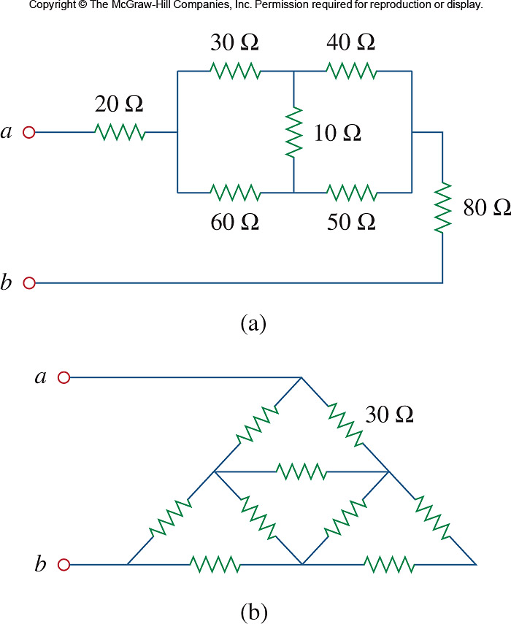
Figure 2.117
For Prob. 2.53.

